**Assignment-3: Type Conversion**

**Q1. Write a python script to convert a number into str type.**

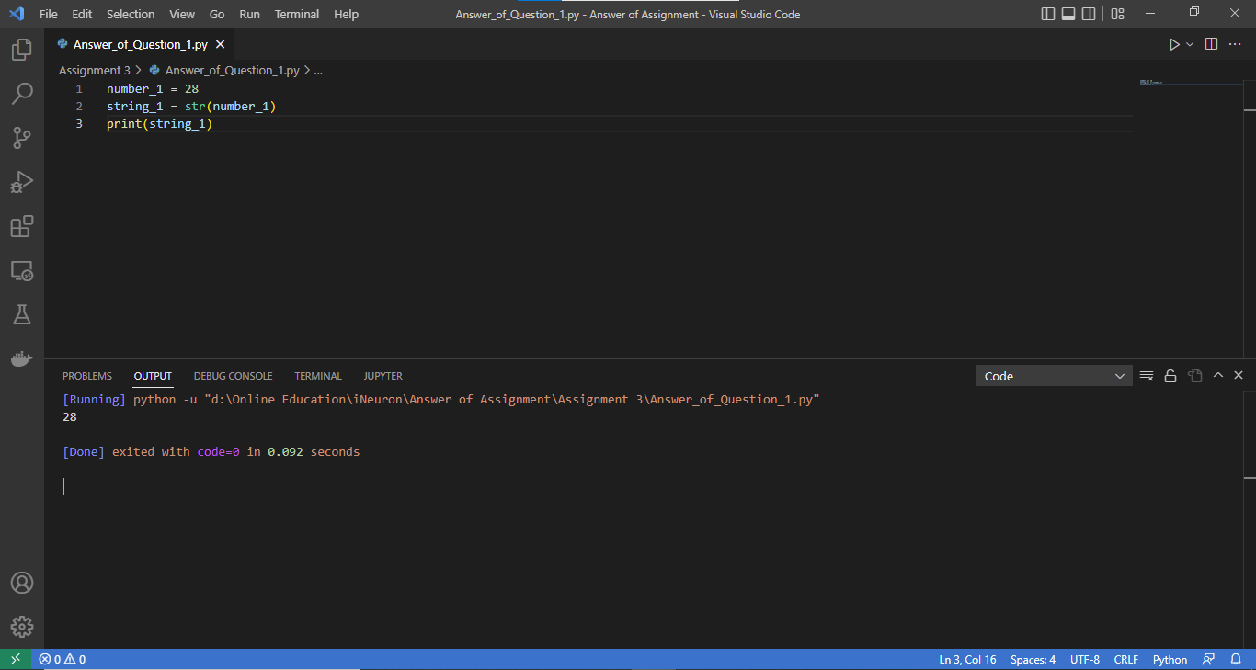

**Q2. Write a python script to print Unicode of the character ‘m’.**

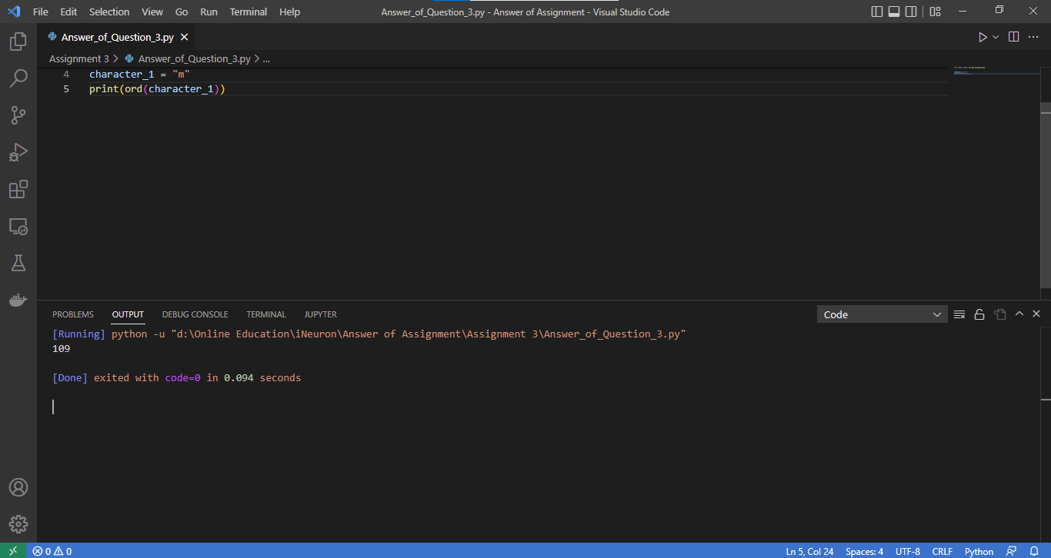

**Q3. Write a python script to print character representation of a given Unicode 100.**

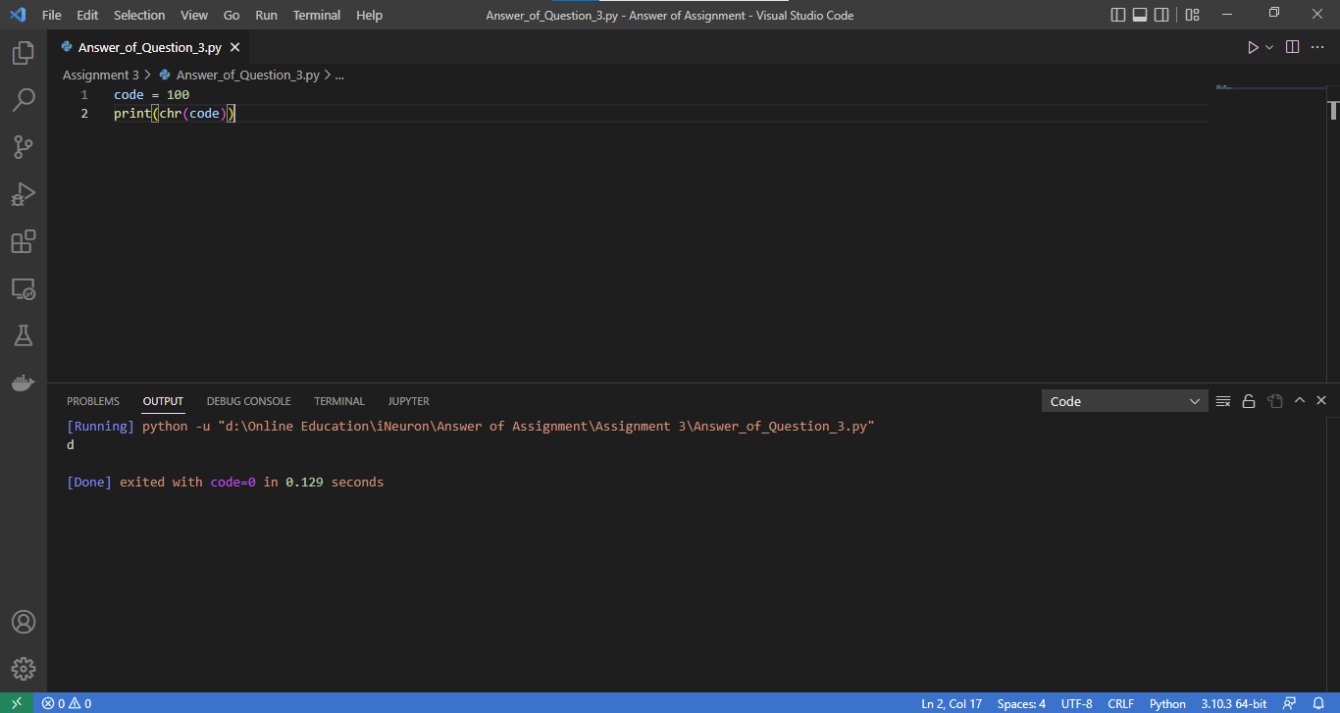

**Q4. Write a python script to print any number and its binary equivalent.**

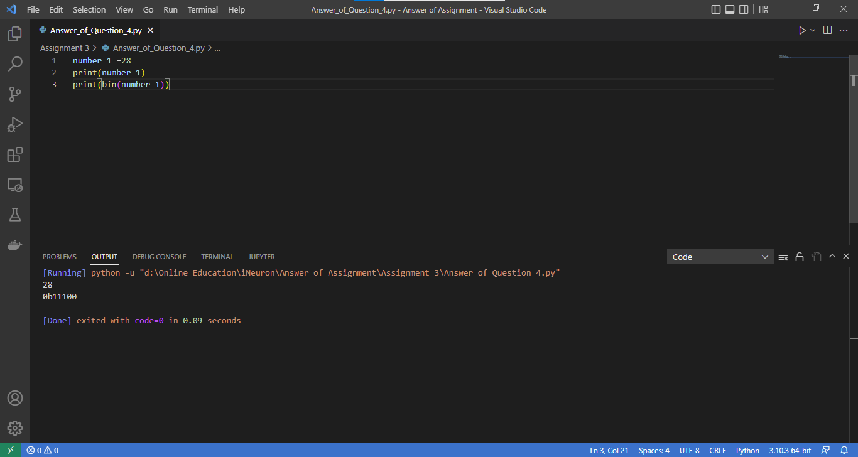

**Q5. Write a python script to print any number and its octal equivalent.**

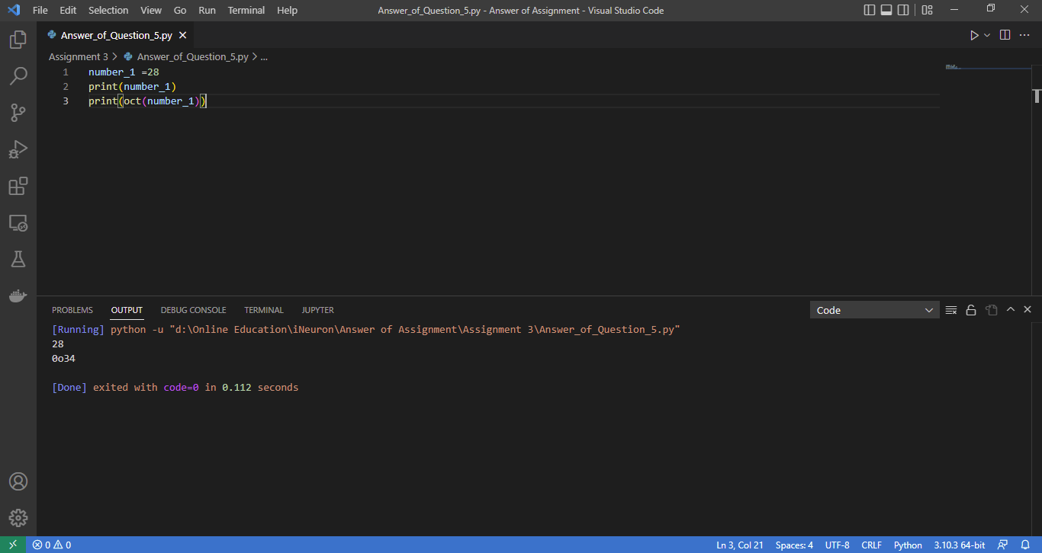

**Q6. Write a python script to print any number and its hexadecimal equivalent.**

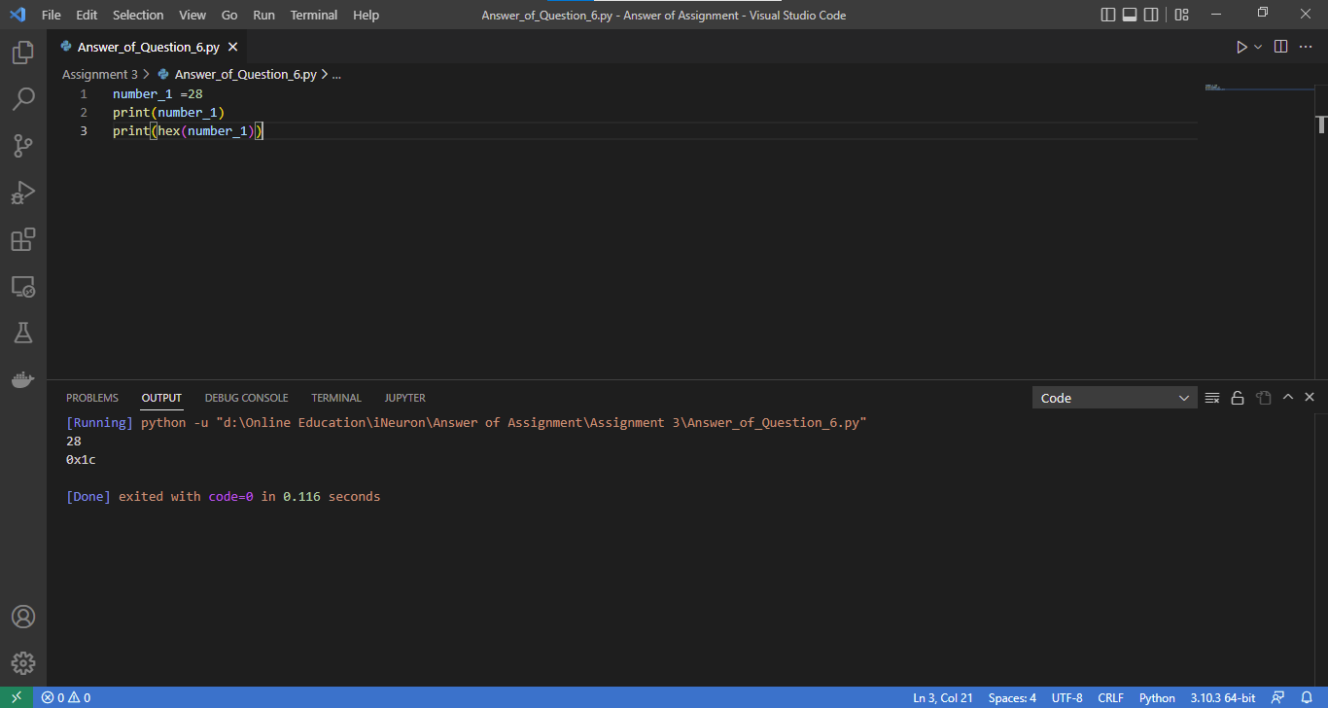

**Q7. Write a python script to store binary number 1100101 in a variable and print it in decimal format.**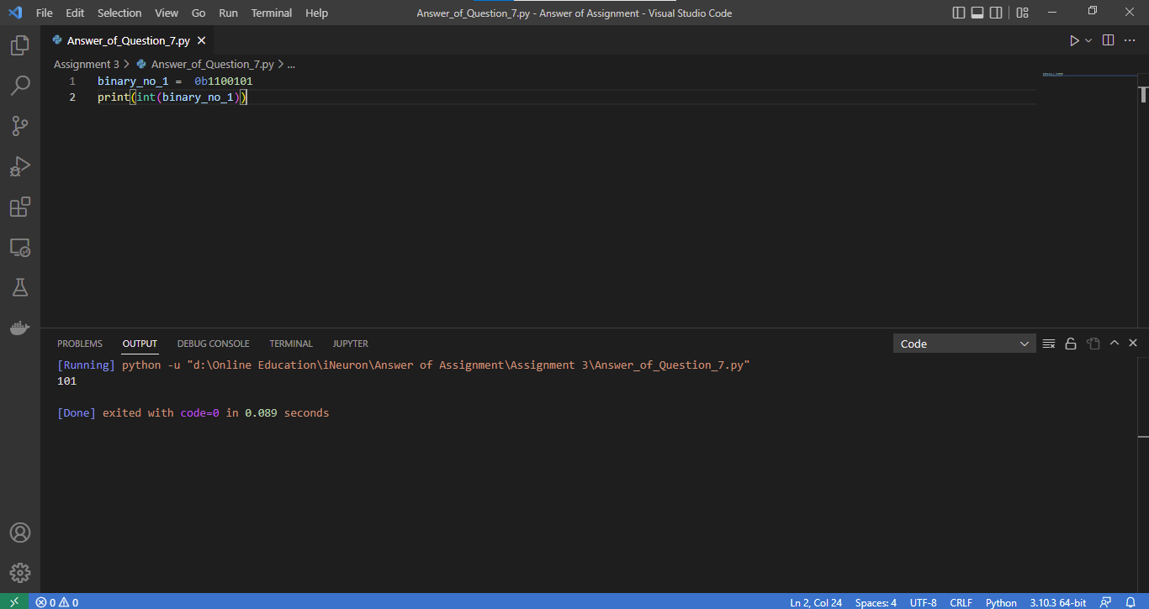

**Q8. Write a python script to store a hexadecimal number 2F in a variable and print it in octal format.**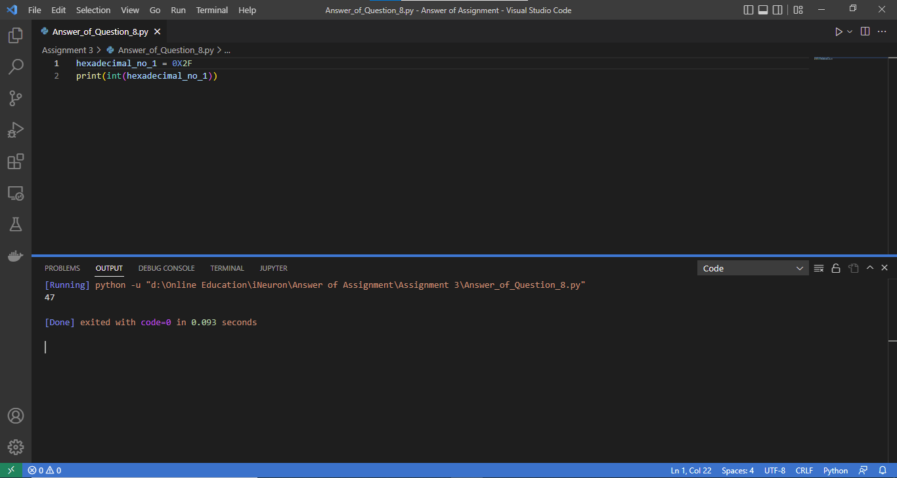

**Q9. Write a python script to store an octal number 125 in a variable and print it in binary format.**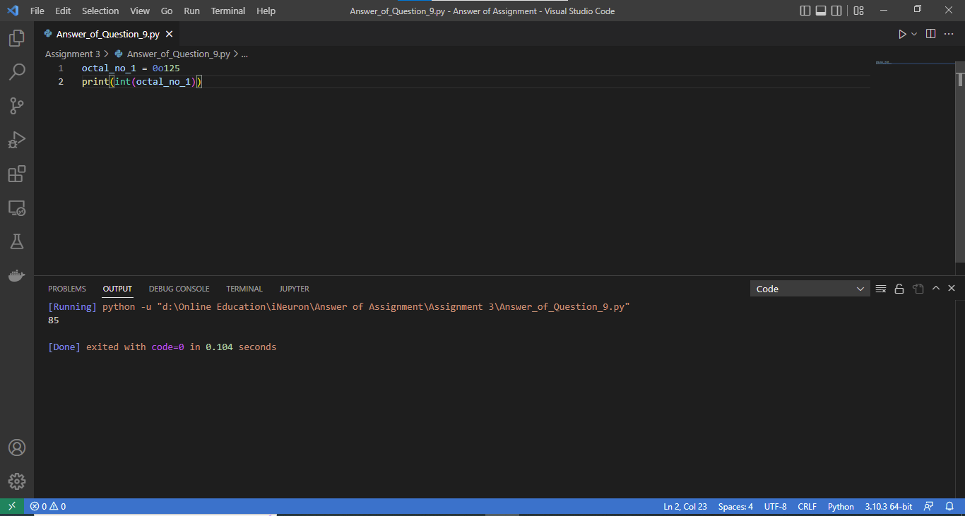

**Q10. Write a python script to add two numbers 25 (in octal) and 39 (in hexadecimal) and display the result in binary format.**

